

**YEAR 12 UNIT 3 HUMAN BIOLOGY**

**TEST 1 ENDOCRINE and NERVOUS SYSTEM**

|  |  |  |  |
| --- | --- | --- | --- |
| **Name:** | **Teacher:** | **Date:** | **Mark:** |

**Assessment Type:** Test

**Conditions:**

Time for the task: 55 minutes

**Task Weighting: 5%**

|  |  |  |
| --- | --- | --- |
| **Sections** | **Marks Allocation** | **Your Total** |
| **1 - Multiple Choice** | 10 |  |
| **2 – Short Answer** | 40 |  |
| **3 – Extended Answer** | 8 |  |
| **TOTAL** | 58 |  |

**Section One: Multiple Choice (10 Marks)**

Suggested working time: 10 minutes.

**The following information is needed to answer the next TWO questions.**

A patient has complained of the following symptoms to their doctor:

* Feeling a lack of energy
* Unexplained weight gain
* Feeling cold, even though the surrounding temperature is around 25°C.

In response, the doctor had the patient’s Thyroid Stimulating Hormone (TSH) levels tested over five consecutive days.

1. TSH is a hormone secreted by:
2. the hypothalamus and released from the anterior lobe of pituitary gland.
3. the posterior lobe of the pituitary gland and its release is controlled by the hypothalamus.
4. the anterior lobe of the pituitary gland and its release is controlled by the thyroid gland.
5. the anterior lobe of the pituitary gland and its release is controlled by the hypothalamus.
6. Based on the information the patient provided, the disease the doctor was most likely checking for was:
7. type 1 diabetes.
8. type 2 diabetes.
9. hypothyroidism.
10. hyperthyroidism.
11. The grey matter of the brain is associated with the cerebral cortex. However, it is also found in other locations including:
12. wherever there are fissures.
13. the entire surface of the central nervous system.
14. the frontal lobes.
15. the centre of the spinal cord.
16. The calcium levels in the blood are controlled by hormones secreted by the
17. hypothalamus
18. anterior pituitary gland
19. parathyroid gland
20. pancreas

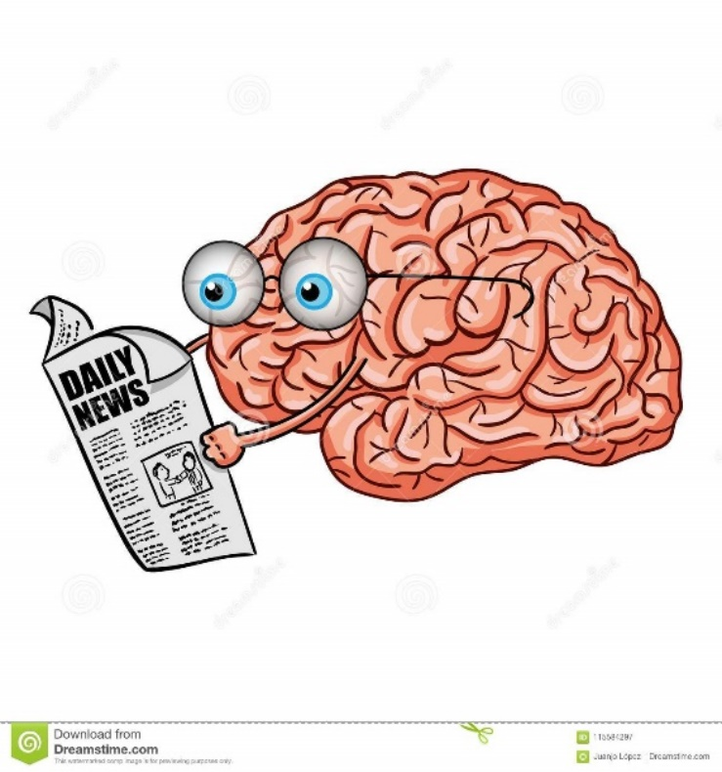

1. The brain part which regulates posture is the:
2. cerebellum.
3. hypothalamus.
4. medulla.
5. cerebrum.

**Refer to the diagram below to answer the next question.**

1. Which of the following correctly identifies the structures of the central nervous system?

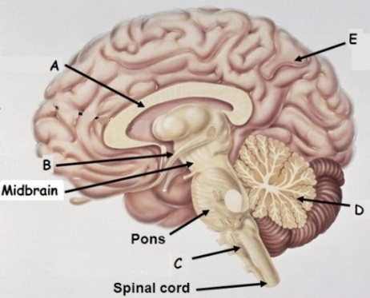

|  |  |  |  |  |  |
| --- | --- | --- | --- | --- | --- |
|  | A | B | C | D | E |
|  | Cerebellum | Hypothalamus | Corpus Callosum | Cerebrum | Pituitary Gland |
|  | Corpus Callosum | Hypothalamus | Medulla Oblongata | Cerebellum | Cerebrum |
|  | Hypothalamus | Corpus Callosum | Medulla Oblongata | Cerebellum | Cerebrum |
| d) | Corpus Callosum | Hypothalamus | Cerebellum | Medulla Oblongata | Cerebrum |

1. Which one of the following is an example of an effector in a reflex arc?
2. Pain receptor in foot.
3. Motor nerve fibres in the spinal cord.
4. Motor end plate.
5. Skeletal muscle.
6. If the ventral root of a spinal cord is cut what will be the result in the tissue or region that the nerve supplies?
7. Complete loss of sensation.
8. Complete loss of voluntary movement.
9. Loss of neither sensation nor movement but only autonomic control.
10. A complete loss of both sensation and movement.
11. In an experiment on mature female rats the pituitary gland was removed. Which of the following would remain UNAFFECTED?
12. Adrenalin secretion from the adrenal gland
13. Secretion of oestrogen from the ovary
14. Thyroxine secretion from the thyroid gland
15. Water retention by the kidney
16. The Corpus Callosum is found just under the cerebrum, its function is to:
17. enable communication between the cerebrum and the cerebellum.
18. protect the hypothalamus.
19. enable the hypothalamus to connect with the pituitary.
20. enable the two sides of the cerebrum to communicate with each other.

**Section Two: Short Answer (40 Marks)**

Suggested working time: 40 minutes.

**Question 1 (4 marks)**

Hyperventilation can occur voluntarily or involuntarily. It can occur involuntarily in response to severe pain or extreme fear.

Complete the following table to distinguish between the two different efferent nervous divisions that can regulate hyperventilation.

|  |  |  |
| --- | --- | --- |
|  | Names of the two efferent divisions of the PNS | |
|  |  |
| Neurotransmitters |  |  |
| Effect of neurotransmitter on  effector(s) / target organ(s) |  |  |
| The number of neurons  between the CNS and effector/target organ |  |  |

(4 marks)

**Question 2 (18 marks)**

Below is an action potential graph showing the outcome from two different stimuli on the same neuron. Look at the graph below and use it to answer the questions that follow.

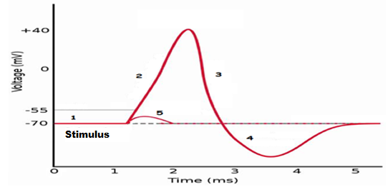

1. The first stimulus resulted in the line labelled with the number 5. Describe what could have occurred here.

_________________________________________________________________________

(1 mark)

1. The second stimulus resulted in the line labelled with the numbers 2, 3 and 4.

Describe TWO events that could not possibly occur during the phases shown by the sections labelled 2, 3 and 4.

_________________________________________________________________________

_________________________________________________________________________

(2 marks)

1. Looking at the action potential graph, locate the section labelled with a 1.

In the box below draw a labelled diagram of this section of the neuron to show:

1. the concentration of the sodium and potassium ions and, if they are moving, the direction the ions would be travelling.
2. the gated ion channels and whether they are open or closed.
3. the charge either side of the neuron membrane.

(4 marks)

1. 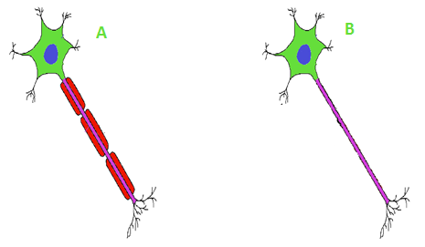Look at the diagram below of the different nerve fibres and answer the questions that follow.

State which nerve fibre shown above is myelinated and whether the myelinated part of the neuron would be found in grey or white matter.

_________________________________________________________________________

(2 marks)

1. Draw an annotated diagram below of a reflex arc ensuring you correctly identify each type of neuron involved

|  |
| --- |
|  |

(5 marks)

1. When a nerve impulse reaches the end of the axon it has to cross the synaptic gap before it can reach the next dendrite and the impulse continue.

Discuss what occurs when a nerve impulse arrives at the pre-synaptic knob in order for it to cross the gap and continue along the next neuron.

_________________________________________________________________________

_________________________________________________________________________

_________________________________________________________________________

_________________________________________________________________________

_________________________________________________________________________

_________________________________________________________________________

_________________________________________________________________________

_________________________________________________________________________

(4 marks)

**Question 3. (18 marks)**

1. The pituitary gland is sometimes referred to as the “master gland”, however, it could be argued the hypothalamus should have this title. Describe how the hypothalamus controls the secretion of hormones from the anterior and posterior lobe of the pituitary gland.

__________________________________________________________________________________________________________________________________________________

_________________________________________________________________________

_________________________________________________________________________

_________________________________________________________________________

_________________________________________________________________________

_________________________________________________________________________

(6 marks)

1. The pituitary gland releases a variety of hormones into the blood stream. Two hormones made by the pituitary are stated in the table below. Complete the table in relation to each of these hormones.

|  |  |  |
| --- | --- | --- |
| Hormone | Target cells/Organs | Function/s or Effects |
| FSH |  |  |
| ACTH |  |  |

(4 marks)

* 1. On the outline diagram below, draw an annotated diagram of the mode of action of a water soluble hormone



(3 marks)

* 1. Insulin is a protein based hormone whereas cortisol is a steroid based hormone. Explain briefly the differences in the ways the two types of hormones bring about a response in the cell.

_________________________________________________________________________

_________________________________________________________________________

_________________________________________________________________________

_________________________________________________________________________

_________________________________________________________________________

(2 marks)

* 1. Both the nervous system and endocrine system communicate within the body but do so in differing ways that complement each other. Compare three differences in the way the nervous system and endocrine system communicate.

_________________________________________________________________________

_________________________________________________________________________

_________________________________________________________________________

_________________________________________________________________________

_________________________________________________________________________

(3 marks)

**Section Three: Extended answer (8 Marks)**

Suggested working time: 10 minutes.

Bill is in a panic, he is late for his bus. He can see it clearly in the distance and he is sprinting to get there. He needs lots of oxygen, he needs lots of glucose and he needs it now!

Identify which part of the nervous system would be activated and explain how it prioritises the energy Bill needs for his fast working muscles.

_________________________________________________________________________

_________________________________________________________________________

_________________________________________________________________________

_________________________________________________________________________

_________________________________________________________________________

_________________________________________________________________________

_________________________________________________________________________

_________________________________________________________________________

_________________________________________________________________________

_________________________________________________________________________

_________________________________________________________________________

_________________________________________________________________________

_________________________________________________________________(8 marks)

**END OF TEST**